Mac RDP Client Setup Instructions

- Make sure to choose the file for RDC2beta.dmg, once this is downloaded it should open up the finder window as shown below.
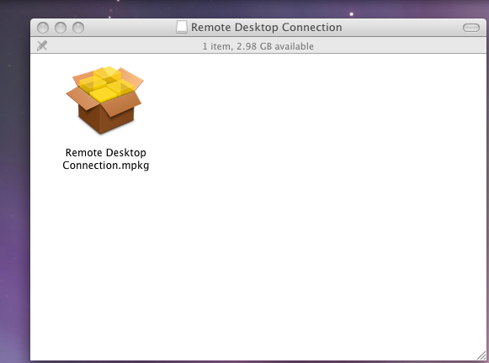

- Double-click the Remote Desktop Connection Icon in the window to start the installer, you can click continue through the installer and agree to licensing.

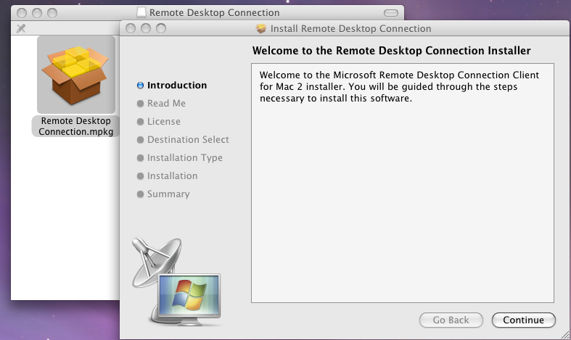

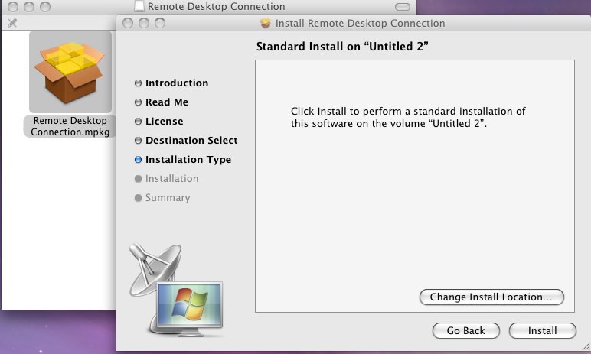

And then the install successful:

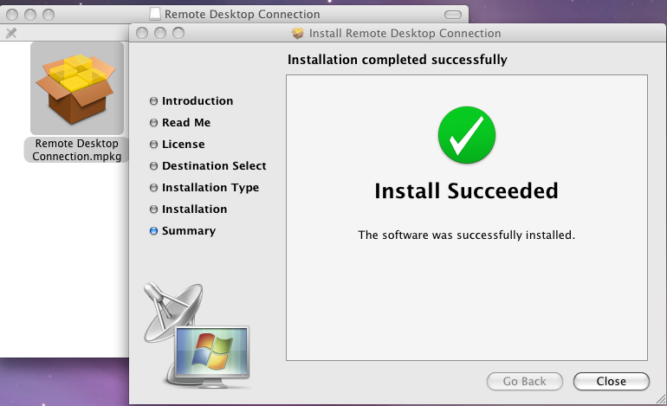

- Open the Applications folder and find the Remote Desktop Connection . Drag the icon to your dock as shown below

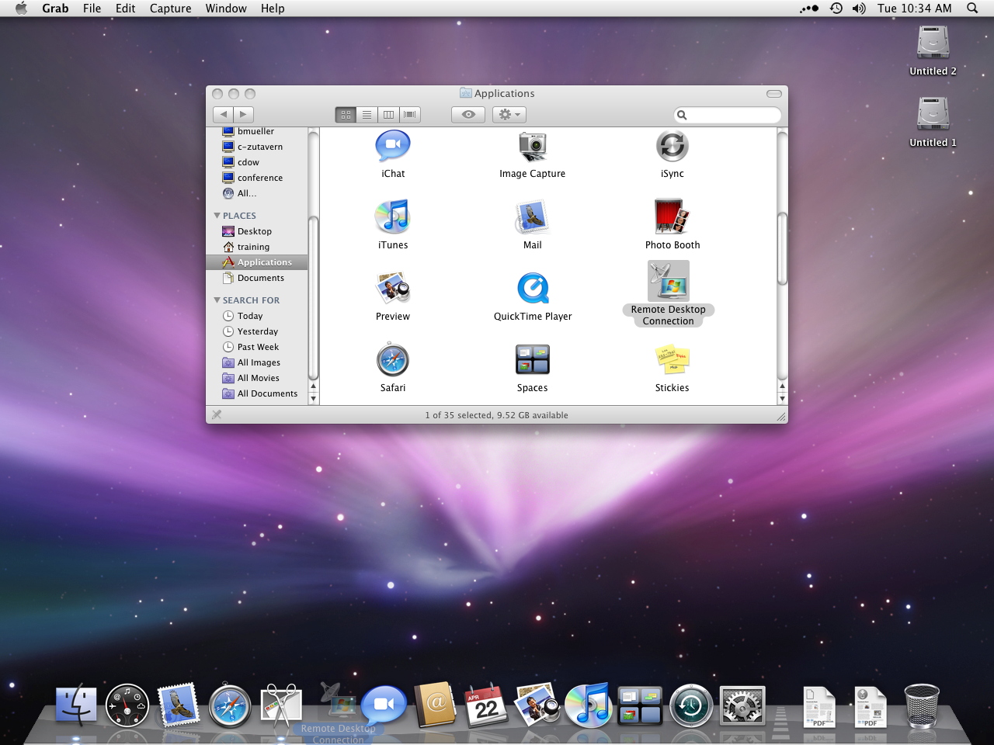

- Click on the icon on your dock for Remote Desktop Connection and it will then open a new window.

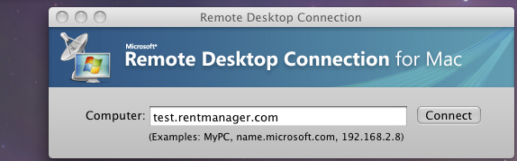
- Enter your Company or Server name in the computer field as shown above, and then click the drop-down for RDC next to your Apple icon at the top.(This only needs to be done if you have not downloaded an icon from our web-page)

- Once you have opened the preferences fill out the information for user name and password if you are the only person using the computer.

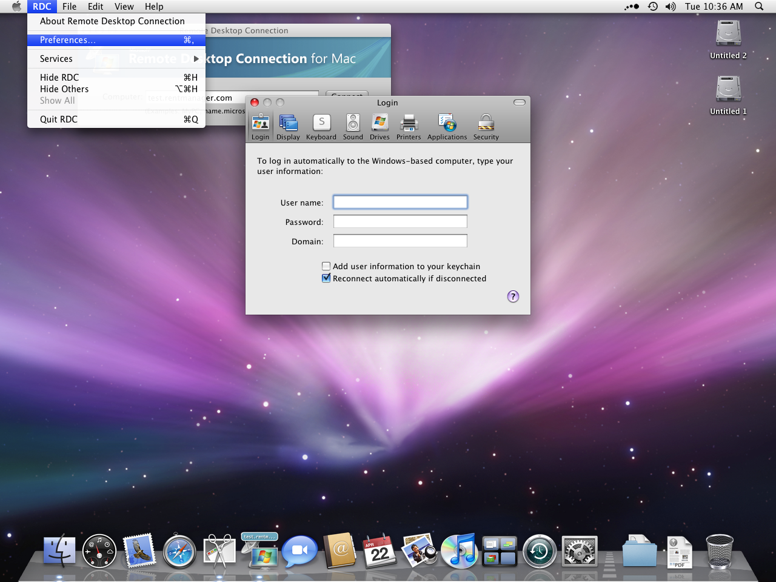
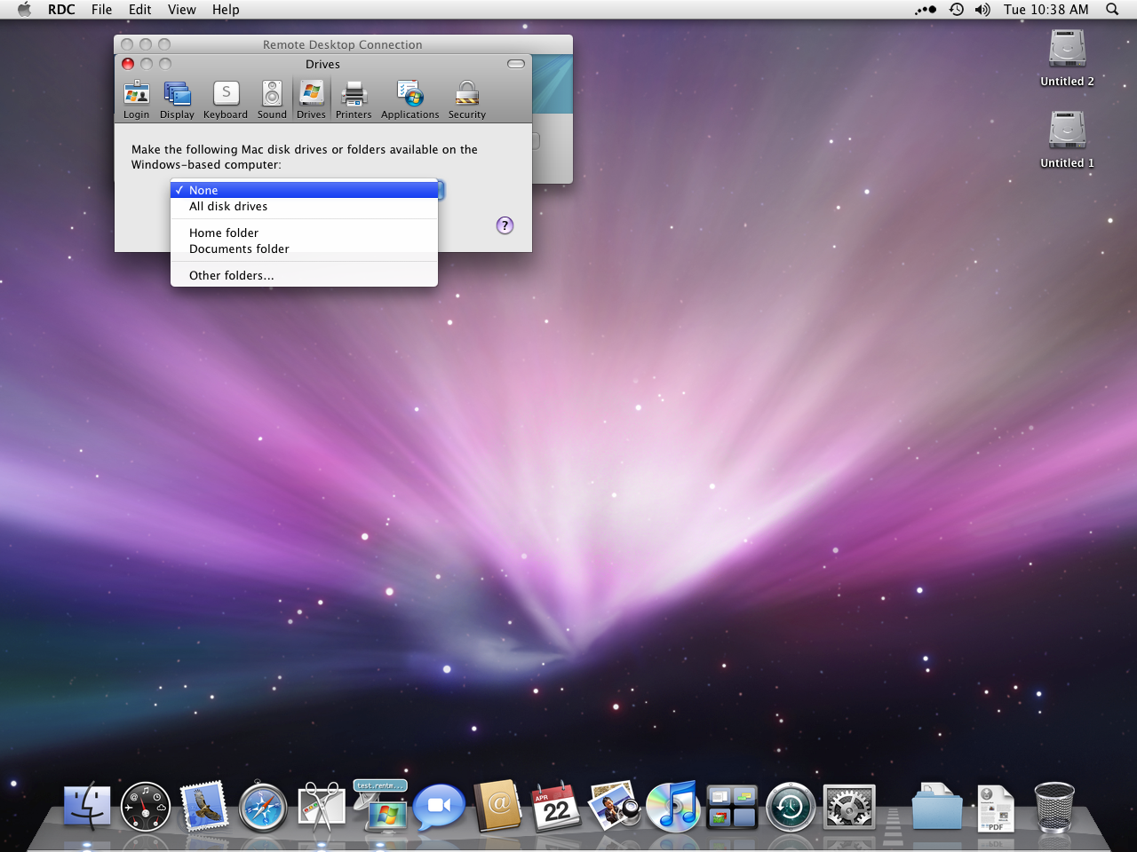
The Domain needs to be filled in needs to say RMO even if you are not putting your user name and password in the system.

Click on the Drives icon at the top and choose your home folder to share if you want to be able to access your local drives from the server once connected..

Click on the Printers icon and make sure to choose print to a printer connected to the Mac and then choose which printer you want to use.

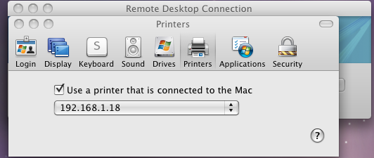

- Once you have the prior options selected close the screen, then click connect from the Remote Desktop Connection window.

- When running the program the next time you will only have to double click Remote Desktop Connection in Applications and then click connect.

